**Read me file for Project Rate my Singing**

Firebase Auth used to gain a unique id while user logs in.

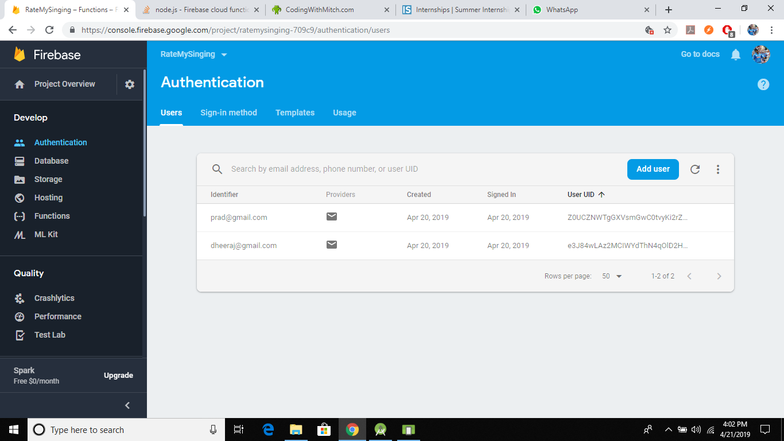

Tree structure as demanded by you for storing comments and keeping track of counts

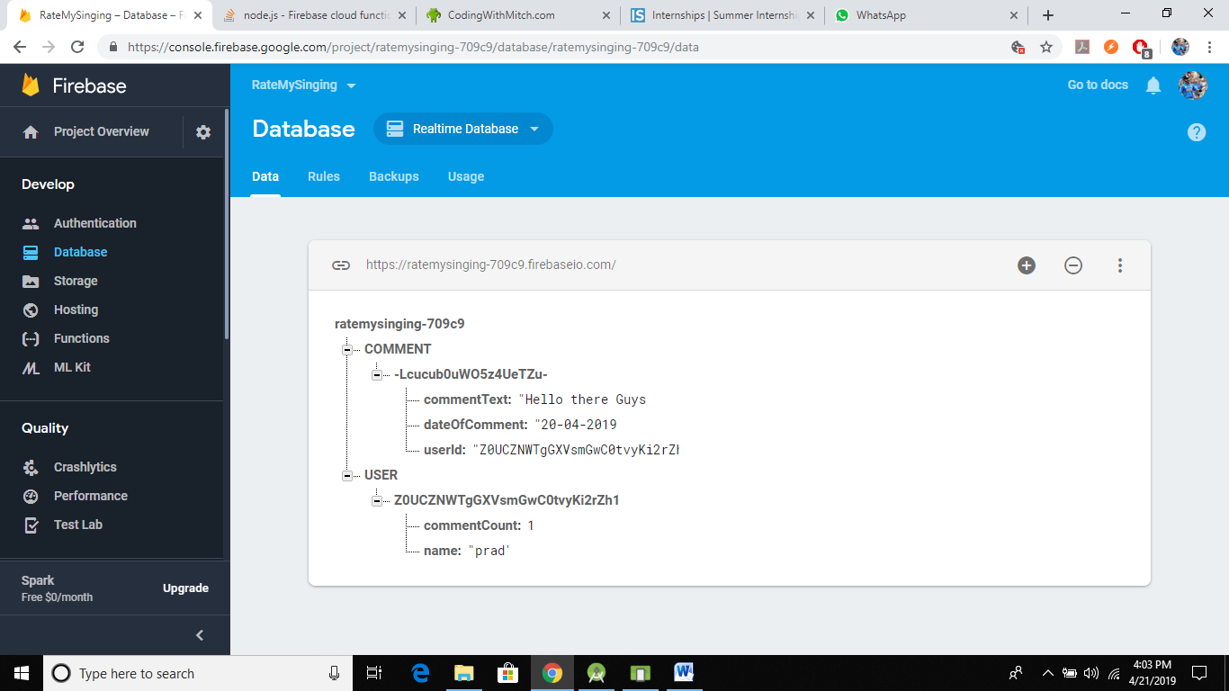

Login page for existing user simultaneously Sign up page for new users.

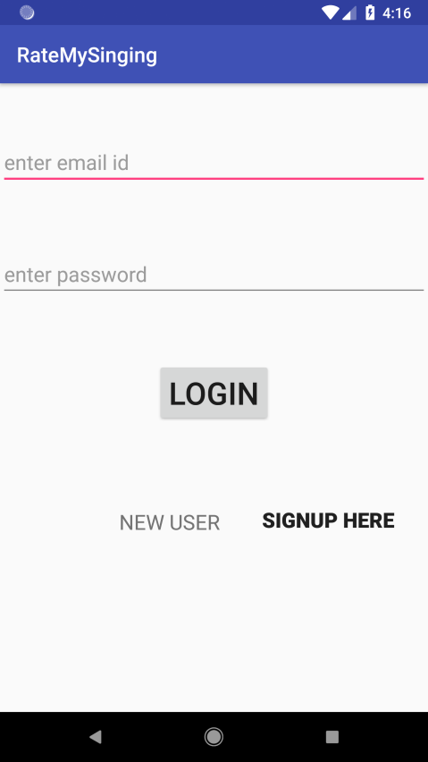 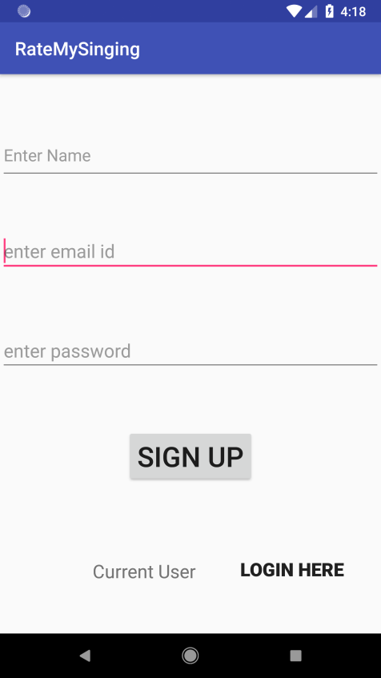

Here we can see the existing comments and simultaneously add new comments and logout from the app inside the menu bar.



Here we can add a new comment which will get posted on the app.

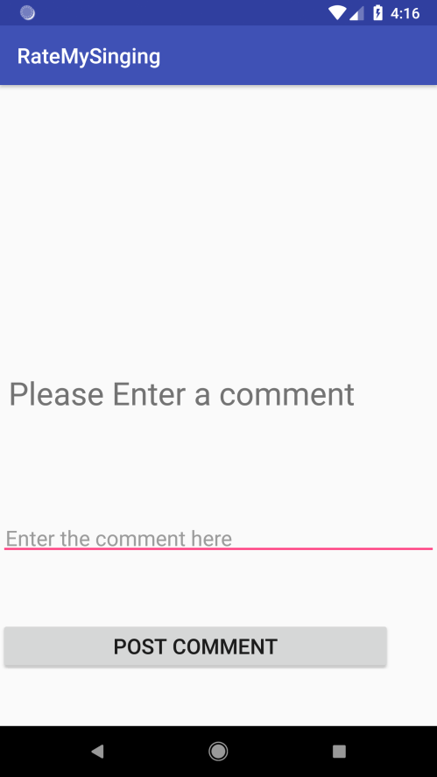

**Function for incrementing counter for a comment**

'use strict';

const functions = require('firebase-functions');

const admin = require('firebase-admin');

admin.initializeApp();

exports.countComment = functions.database.ref('/COMMENT/{comment_id}').onWrite(

async ((change:any)) => {

const uid = change.after.child('userId');

const countRef = admin.database().ref("/USER/"+uid+"/commentCount");

let increment;

if (change.after.exists() && !change.before.exists()) {

increment = 1;

}

else if (!change.after.exists() && change.before.exists()) {

increment = -1;

}

else {

return null;

}

await countRef.transaction(((current:any)) => {

return (current || 0) + increment;

});

console.log('Counter updated.');

return null;

});